GURUHLI MASHG‘ULOT UCHUN O‘QUV MATERIALLARI

2-Mavzu: PyQt5 paketi va QtDesigner dasturi yordamida GUI dasturlarini yaratish.
3-mashg‘ulot. PyQt5 kutubxonasi. QLineEdit vidjeti.
O‘quv savollari:
1. QLineEdit vidjeti;
2. setStyleSheet() metodi.

1. QLineEdit vidjeti
QLineEdit - bu matnning bir qatorini kiritish va tahrirlash imkonini beruvchi vidjet. Ushbu vidjetda Cencel va Repeat, Cut va Past hamda “Sudrab olib tashlash” funksiyalari mavjud.
import sys
from PyQt5.QtWidgets import (QWidget, QLabel,
QLineEdit, QApplication)

class Examples(QWidget):
def __init__(self):
super().__init__()

self.initUI()

def initUI(self):
self.lbl = QLabel(self)
qlineE = QLineEdit(self)

qlineE.move(100, 100)
self.lbl.move(100, 40)

qlineE.textChanged[str].connect(self.changed)
self.setGeometry(300, 300, 280, 170)
self.setWindowTitle(‘QlineEdit Example’)
self.show()

def changed(self, text):
self.lbl.setText(Label text)
self.lbl.adjustSize()

if __name__ == ‘__main__’:

app = QApplication(sys.argv)
ex = Examples()
sys.exit(app.exec_())
Ushbu misolda QLineEdit vidjeti va QLabel ko‘rsatilgan. Tahrirlash paneliga kiritgan matnimiz darhol teg vidjetida ko‘rsatiladi.
qlineE = QLineEdit(self)
QLineEdit vidjetining qline obyekti yaratildi.
qlineE.textChanged[str].connect(self.changed)
Agar QLineEdit vidjetidagi matn o‘zgarsa, changed() funksiyasi ishga tushadi.
def changed(self, text):
self.lbl.setText(text Label)
self.lbl.adjustSize()
changed funksiyasining ichida kiritilgan matnni teg vidjetiga o‘rnatish buyrug‘i joylashtirilgan. Yorliq o‘lchamini matn uzunligiga mos ravishda o‘zgartirish uchun adjustSize() metodidan foydalanilgan .
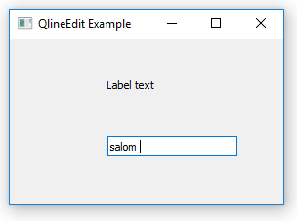
Yuqoridagi dastur ko‘rinishi
PyQt QLineEdit
PyQt QLineEdit bir qatorli matnli vidjet yaratish imkonini beradi. Odatda, siz QLineEditma'lumotlarni kiritish shaklida foydalanasiz .
Amalda siz ko‘pincha QLineEditvidjetni vidjet bilan ishlatasiz QLabel.
Vidjet yaratish uchun QLineEditquyidagi amallarni bajaring.
Birinchidan, moduldan import QLineEditqiling PyQt6.QtWidgets:
from PyQt6.QtWidgets import QLineEditKod tili: Python ( python )
Ikkinchidan, QLineEditfoydalanadigan yangi obyekt yarating:
- Hech qanday dalil yo‘q.
- Faqat ota-ona vidjeti bilan.
- Yoki birinchi argument sifatida standart satr qiymati bilan.
Masalan:
line_edit = QLineEdit('Default Value', self)Kod tili: Python ( python )
Bundan tashqari, siz quyidagi qo‘shimcha xususiyatlardan foydalanishingiz mumkin:
Metod | Turi | Ta’rifi
matn | ip | Satrni tahrirlash mazmuni
readOnly | Mantiqiy | To‘g‘ri yoki noto‘g‘ri. Agar rost boʻlsa, qatorni tahrir qilib boʻlmaydi
clearButtonEnabled | Mantiqiy | Aniq tugmani qo‘shish to‘g‘ri
placeholderText | ip | Satrni tahrirlash bo‘sh bo‘lganda paydo bo‘ladigan matn
maxLength | butun son | Maksimal kiritilishi mumkin bo‘lgan belgilar sonini belgilang
echoMode | QLineEdit.EchoMode | Matnni ko‘rsatish usulini o‘zgartiring, masalan, parol
PyQt QLineEdit vidjetiga misollar
Keling, vidjetdan foydalanishga misollar keltiraylik QLineEdit.
1) Oddiy PyQt QLineEdit misoli
Quyidagi dastur vidjetni qanday yaratishni ko‘rsatadi QLineEdit:
import sys
from PyQt6.QtWidgets import (
QApplication,
QWidget,
QLineEdit,
QVBoxLayout
)

class MainWindow(QWidget):
def __init__(self, *args, **kwargs):
super().__init__(*args, **kwargs)

self.setWindowTitle('PyQt QLineEdit Widget')
self.setGeometry(100, 100, 320, 210)

search_box = QLineEdit(
self,
placeholderText='Enter a keyword to search...',
clearButtonEnabled=True
)

# place the widget on the window
layout = QVBoxLayout()
layout.addWidget(search_box)
self.setLayout(layout)

# show the window
self.show()

if __name__ == '__main__':
app = QApplication(sys.argv)
window = MainWindow()
sys.exit(app.exec())Kod tili: Python ( python )
Chiqish:
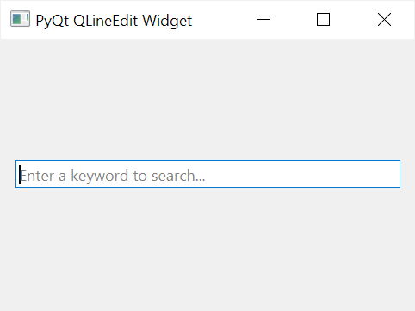
2) Parol yozuvini yaratish uchun PyQt QLineEdit dan foydalanish
Quyidagi dastur QLineEditparol kiritish sifatida yangi vidjet yaratadi:
import sys
from PyQt6.QtWidgets import (
QApplication,
QWidget,
QLineEdit,
QVBoxLayout
)

class MainWindow(QWidget):
def __init__(self, *args, **kwargs):
super().__init__(*args, **kwargs)

self.setWindowTitle('PyQt QLineEdit Widget')
self.setGeometry(100, 100, 320, 210)

password = QLineEdit(self, echoMode=QLineEdit.EchoMode.Password)

# place the widget on the window
layout = QVBoxLayout()
layout.addWidget(password)
self.setLayout(layout)

# show the window
self.show()

if __name__ == '__main__':
app = QApplication(sys.argv)
window = MainWindow()
sys.exit(app.exec())Kod tili: Python ( python )
QLineEditVidjetni parol kiritishiga aylantirish uchun siz echoModeni o‘rnatasiz QLineEdit. EchoMode.Password:
password = QLineEdit(self, echoMode=QLineEdit.EchoMode.Password)Kod tili: Python ( python )
Chiqish:
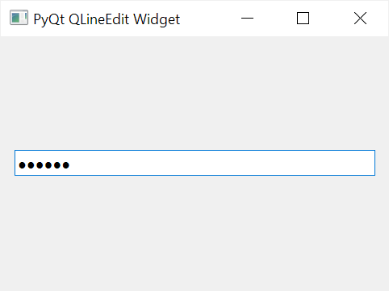
3) PyQt QLineEdit-dan avtomatik to‘ldirish xususiyati bilan foydalanish
Avtomatik to‘ldirish xususiyati bilan yozuv yaratish uchun siz quyidagi amallarni bajaring:
Birinchidan, modulni import QCompleterqiling PyQt6.QtWidgets.
Ikkinchidan, QCompleteravtomatik toʻldirish funksiyasi uchun ishlatiladigan satrlar roʻyxati bilan vidjet yarating:
completer = QCompleter(word_list)Kod tili: Python ( python )
Uchinchidan, a yarating va to‘ldiruvchi obyekt bilan QLineEdituning usulini chaqiring :setCompleter()
line_edit = QLineEdit(self)
line_edit.setCompleter(completer)Kod tili: Python ( python )
Masalan, quyidagi dastur QLineEditavtomatik to‘ldirish xususiyatiga ega vidjetni ko‘rsatadi:
import sys
from PyQt6.QtWidgets import (
QApplication,
QWidget,
QLineEdit,
QVBoxLayout,
QCompleter
)

class MainWindow(QWidget):
def __init__(self, *args, **kwargs):
super().__init__(*args, **kwargs)

self.setWindowTitle('PyQt QLineEdit Widget')
self.setGeometry(100, 100, 320, 210)

common_fruits = QCompleter([
'Apple',
'Apricot',
'Banana',
'Carambola',
'Olive',
'Oranges',
'Papaya',
'Peach',
'Pineapple',
'Pomegranate',
'Rambutan',
'Ramphal',
'Raspberries',
'Rose apple',
'Starfruit',
'Strawberries',
'Water apple',
])
fruit = QLineEdit(self)
fruit.setCompleter(common_fruits)

# place the widget on the window
layout = QVBoxLayout()
layout.addWidget(fruit)
self.setLayout(layout)

# show the window
self.show()

if __name__ == '__main__':
app = QApplication(sys.argv)
window = MainWindow()
sys.exit(app.exec())Kod tili: Python ( python )
Chiqish:
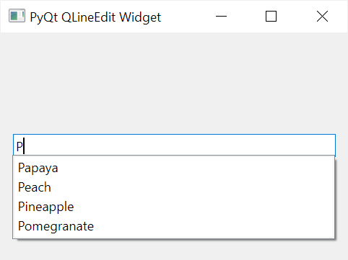
- QLineEditBir qatorli kirish vidjetini yaratish uchun foydalaning .
- echoModeMatnni ko‘rsatish usulini o‘zgartirish uchun xususiyatdan foydalaning .
- QLineEditAvtomatik to‘ldirish funksiyasini qo‘llab-quvvatlash uchun vidjetdan QCompleter vidjeti bilan foydalaning .
Nazorat savollari:
- PyQt da yorliq yaratish uchun qaysi vidgetdan foydalaniladi?
- QLineEdit vidjetining vazifasi qanday?
- QLineEdit vidjetining xususiyatlari qanday?

